迁移 MySQL 数据到 OceanBase 集群

一、目标
搭建mysql数据库，使用tpcc创建模拟数据。
使用 mysqldump 将 mysql的表结构和数据同步到 OceanBase 的MySQL 租户中。
使用 datax 配置至少一个表的 MySQL 到 OceanBase 的 MySQL 租户的离线同步。

二、安装mysql数据库

1.解压安装启动mysql
tar -xvf mysql-5.7.25-linux-glibc2.12-x86_64.tar.gz -C /soft/mysql
mkdir -p /data/mysql/data
groupadd mysql
useradd -g mysql mysql
chown -R mysql.mysql /soft/mysql
chown -R mysql.mysql /data/mysql/data
添加配置文件
vi /etc/my.cnf
[mysqld]
port=3306
user=mysql
basedir=/soft/mysql
datadir=/data/mysql/data
socket=/tmp/mysql.sock
#character config
character_set_server=utf8mb4
server_id=6
初始化数据库,密码为空
mysqld --defaults-file=/etc/my.cnf --basedir=/soft/mysql/ --datadir=/data/mysql/data --user=mysql --initialize-insecure
重置密码
mysqladmin -uroot -p password 111111
配置环境变量：
vi /etc/profile
export LANG=en_US.UTF-8
export PATH=$PATH:/soft/mysql/bin #mysql安装路径
export MYSQL_HISTFILE=/dev/null
> ~/.mysql_history

检查操作系统上是否安装了MySQL
rpm -qa |grep mariadb
yum remove mysql-libs

配置启动文件到开机初始化目录
cp -r /soft/mysql/support-files/mysql.server /etc/init.d/mysqld
chkconfig mysqld on
配置启动方式
/etc/init.d/mysqld start

2.建库建表
1.下载编译mysql tpcc测试程序及脚本，并进行编译。
https://github.com/Percona-Lab/tpcc-mysql/archive/refs/heads/master.zip
unzip tpcc-mysql-master.zip
cd tpcc-mysql-master/src/
Make
2.创建数据库，并导入tpcc建表脚本
mysql> create database ygbdb;
Query OK, 1 row affected (0.00 sec)
mysql> use ygbdb;
Database changed
mysql> source /home/mysql/tpcc-mysql-master/create_table.sql
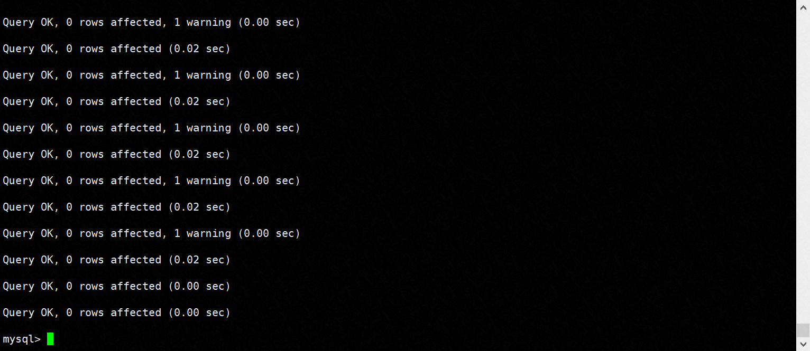
导入测试数据
./tpcc_load -h127.0.0.1 -P3306 -d ygbdb -uroot -w 2 -p111111
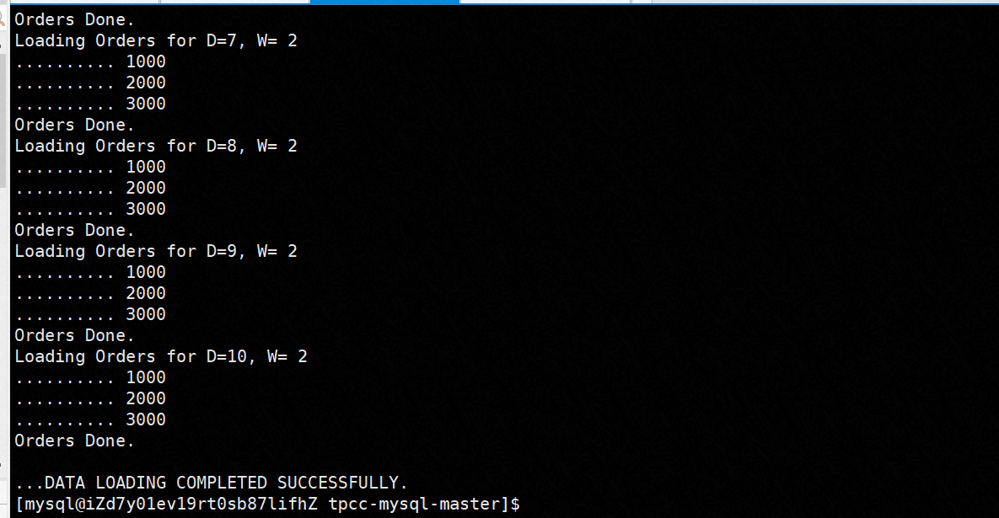

mysqldump导出数据
使用 mysqldump 将 mysql的表结构和数据同步到 OceanBase 的MySQL 租户中

1.导出mysql数据
# 导出表结构
mysqldump -h127.0.0.1 -P3306 -p111111 -uroot -d ygbdb --compact > tpcc_ddl.sql
# 导出数据
mysqldump -h127.0.0.1 -P3306 -p111111 -uroot -t ygbdb --compact > tpcc_data.sql
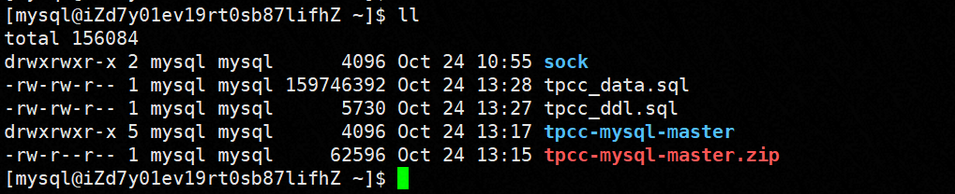

2.导入OceanBase
-- 连接ob数据库
obclient -h127.1 -uroot@ob_tent_ygb#obdemo -P2883 -p -A -c
MySQL [(none)]> use obtest
Database changed
-- 导入表结构
MySQL [obtest]> source /home/admin/tpcc_ddl.sql
-- 导入数据
MySQL [obtest]> source /home/admin/tpcc_data.sql

-- 验证
Show tables;

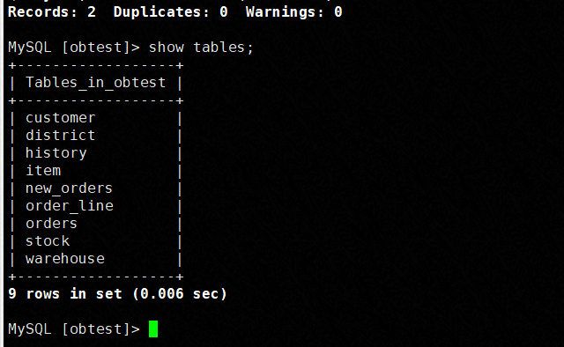

使用 datax 配置至少一个表的 MySQL 到 OceanBase 的 MySQL 租户的离线同步

1.安装datax
datax下载地址：http://datax-opensource.oss-cn-hangzhou.aliyuncs.com/datax.tar.gz
tar /zxvf /opt/software/datax.tar.gz

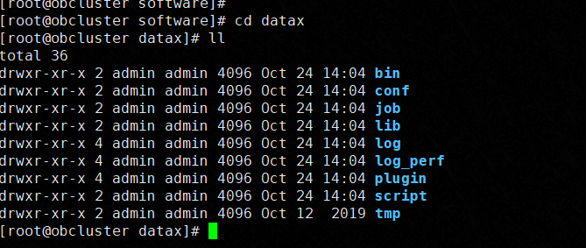

2、安装jkd1.8
tar /zxvf jdk-8u291-linux-x64.tar.gz
Admin用户配置环境变量
[admin@obcluster software]$ more ~/.bash_profile
# .bash_profile

# Get the aliases and functions
if [ -f ~/.bashrc ]; then
. ~/.bashrc
fi

# User specific environment and startup programs

PATH=$PATH:$HOME/.local/bin:$HOME/bin

export PATH
export LD_LIBRARY_PATH=:/home/admin/oceanbase/lib
export JAVA_HOME=/home/admin/jdk1.8.0_291
export JRE_HOME=${JAVA_HOME}/jre
export CLASSPATH=.:${JAVA_HOME}/lib:${JRE_HOME}/lib
export PATH=${JAVA_HOME}/bin:$PATH
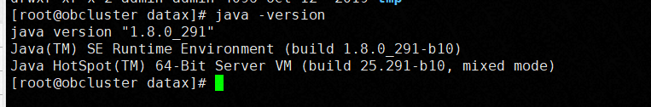

编写mysql同步到ob的json文件
源端mysql ： 196.36.135.24:3306/ygbdb
目标端ob: -h196.36.231.16 -uroot@ob_tent_ygb#obdemo -P2883 -p111111
同步表 ：district

vi ./datax/job/wang.json
{
"job": {
"setting": {
"speed": {
"channel": 2,
},
"errorLimit": {
"record": 10
}
},
"content": [
{
"reader": {
"name": "mysqlreader",
"parameter": {
"username": "root",
"password": "111111",
"column": [
"*"
],
"connection": [
{
"jdbcUrl": [
"jdbc:mysql://196.36.135.24:3306/ygbdb"
],
"table": [
"district"
]
}
]
}
},
"writer": {
"name": "oceanbasev10writer",
"parameter": {
"writeMode": "insert",
"username": "root",
"password":"111111",
"writerThreadCount": 5,
"column": [
"*"
],
"connection": [
{
"jdbcUrl": "||_dsc_ob10_dsc_||obdemo:ob_tent_ygb||_dsc_ob10_dsc_||jdbc:mysql://196.36.231.16:2883/mysql2ob_db?useUnicode=true&characterEncoding=utf-8",
"table": [
"district"
]
}
]
}
}
}
]
}
}

4.datax执行迁移
python /opt/software/datax/bin/datax.py /home/admin/mysql2ob.json
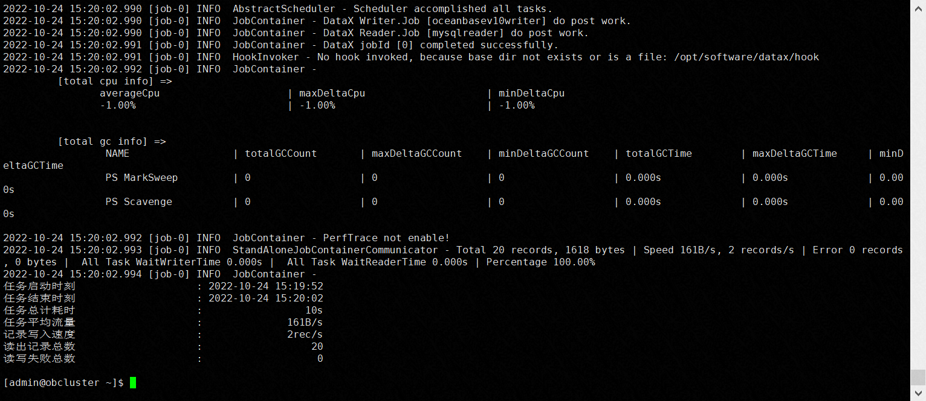确认数据量：

