## 实践练习六（必选）：查看 OceanBase 执行计划

本次练习是必选练习之一。

练习目的

本次练习目的掌握 OceanBase 的执行计划查看方法，包括 explain 命令和查看实际执行计划。

练习条件

有服务器，内存资源至少 12G*1 台，部署有 OceanBase 集群（单副本或三副本都可以）。

练习内容

请记录并分享下列内容：

（必选）1、使用 BenmarkSQL 运行 TPC-C ，并发数不用很高，5~10 并发即可（根据机器资源）。

（必选）2、分析 TPC-C TOP SQL，并查看 3条 SQL 的 解析执行计划 和 实际执行计划。

**一、服务器信息**

|  |  |
| --- | --- |
| IP地址 | 10.0.14.22 |
| 网卡名 | enp0s8 |
| OS | CentOS Linux release 7.8.2003 (Core) |
| CPU | 16C |
| 内存 | 20G |
| 磁盘1 | 本地盘 /dev/sdd (lvm /data 、 /redo) |

二、参数设置

2.1、OS 参数

sh -c 'for x in /sys/class/net/enp0s8/queues/rx-*; do echo ff>$x/rps_cpus; done'

sh -c "echo 32768 > /proc/sys/net/core/rps_sock_flow_entries"

sh -c "echo 4096 > /sys/class/net/eth0/queues/rx-0/rps_flow_cnt"

#### 2.2、OceanBase 参数

##### 2.2.1 SYS 租户参数

obclient -h 10.0.14.22 -P 2883 -uroot@sys#obcluster -p -c -A oceanbase

alter system set enable_auto_leader_switch=false;

alter system set enable_one_phase_commit=false;

alter system set enable_monotonic_weak_read = true;

alter system set weak_read_version_refresh_interval='5s';

alter system _ob_minor_merge_schedule_interval='5s';

alter system set memory_limit_percentage = 90;

alter system set memstore_limit_percentage = 55;

alter system set freeze_trigger_percentage = 70;

alter system set minor_freeze_times = 50;

alter system set minor_warm_up_duration_time = 0;

alter system set merge_thread_count = 32;

alter system set minor_merge_concurrency = 8;

alter system set _mini_merge_concurrency = 4;

##### 2.2.2 PROXY 参数

alter proxyconfig set proxy_mem_limited='4G'; --防止 oom，可根据实际环境动态调整

alter proxyconfig set enable_compression_protocol=false; --关闭压缩，降低 CPU 百分率

alter proxyconfig set work_thread_num=32; -- 调整工作线程数，寻找最优性能

alter proxyconfig set enable_compression_protocol=false;

alter proxyconfig set enable_metadb_used=false;

alter proxyconfig set enable_standby=false;

alter proxyconfig set enable_strict_stat_time=false;

alter proxyconfig set use_local_dbconfig=true;

create database tpcc;

unzip benchmarksql-5.0-master.zip

##### 3.2 配置

编辑 /root/benchmarksql/run/props.ob 目录下,编辑后的内容如下:

db=mysql

driver=com.alipay.oceanbase.obproxy.mysql.jdbc.Driver

conn=jdbc:oceanbase://127.0.0.1:2883/tpcc?useUnicode=true&characterEncoding=utf-8user=root@sys#obcluster password=123456

warehouses=2

loadWorkers=10

terminals=10

//To run specified transactions per terminal- runMins must equal zero

runTxnsPerTerminal=0

//To run for specified minutes- runTxnsPerTerminal must equal zero

runMins=1

//Number of total transactions per minute

limitTxnsPerMin=0

//Set to true to run in 4.x compatible mode. Set to false to use the

//entire configured database evenly.

terminalWarehouseFixed=true

//The following five values must add up to 100

newOrderWeight=45

paymentWeight=43

orderStatusWeight=4

deliveryWeight=4

stockLevelWeight=4

// Directory name to create for collecting detailed result data.

// Comment this out to suppress.

resultDirectory=my_result_%tY-%tm-%td_%tH%tM%tS

osCollectorScript=./misc/os_collector_linux.py

osCollectorInterval=1

##### 3.3 运行创建表语句

sh runSQL.sh props.ob sql.common/tableCreates.sql

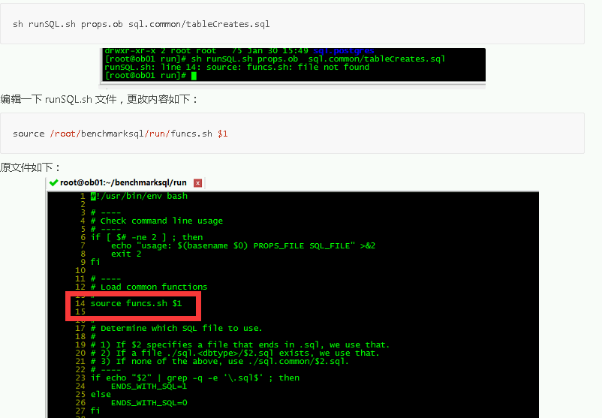

##### 四、测试

##### 4.1 加载数据

sh runLoader.sh props.ob

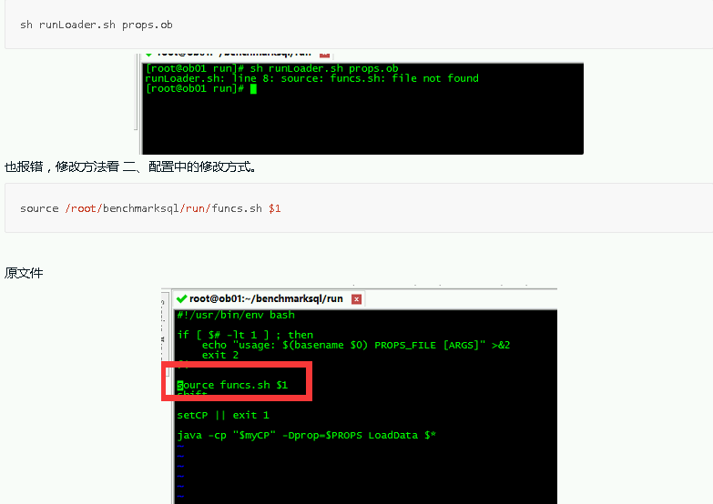

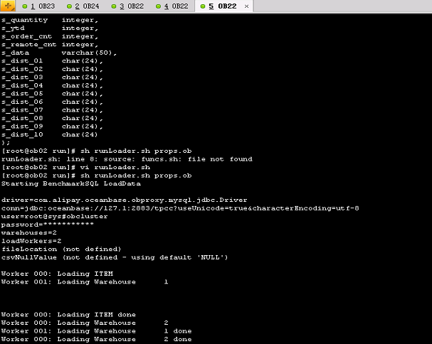

##### 4.2 创建索引

##### ##登陆到数据库,创建两个索引(表上之前是没有索引的)

[root@ob02 run]# obclient -h 10.0.14.22 -uroot@sys#obcluster -P2883 -p'123456' -c -A tpcc

create index bmsql_customer_idx1 on bmsql_customer (c_w_id, c_d_id, c_last, c_first) local;

create index bmsql_oorder_idx1 on bmsql_oorder (o_w_id, o_d_id, o_carrier_id, o_id) local;

##### **4.3 执行性能测试**

sh runBenchmark.sh props.ob

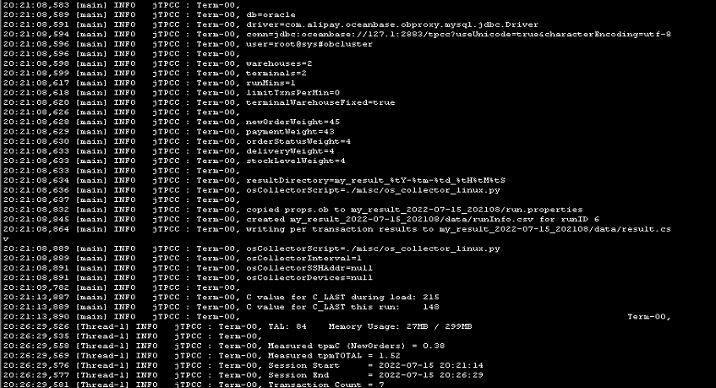

#### 五、TPC-C TOP SQL分析

#### 5.1 查询TOP10 sql

SELECT sql_id, count(*), round(avg(elapsed_time)) avg_elapsed_time, round(avg(execute_time)) avg_exec_time

       FROM gv$sql_audit s

       WHERE 1=1

        and user_name='tpcc'

        and request_time >= time_to_usec(DATE_SUB(current_timestamp, INTERVAL 30 MINUTE) )

       GROUP BY sql_id

       order by avg_elapsed_time desc limit 10;

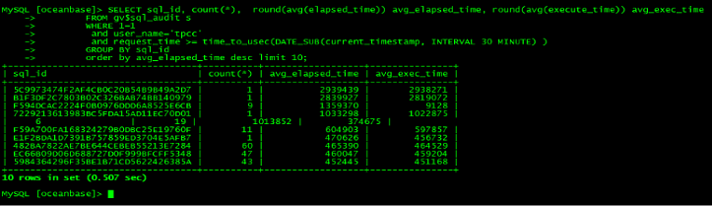

##### 5.2 对 elapsed 时间最长的前三条 sql 进行分析

SELECT sql_id, count(*), round(avg(elapsed_time)) avg_elapsed_time,

                     round(avg(execute_time)) avg_exec_time,

                     s.svr_ip,

                     s.svr_port,

                     s.tenant_id,

                     s.plan_id

                    FROM gv$sql_audit s

                    WHERE 1=1

                     and request_time >= time_to_usec(DATE_SUB(current_timestamp, INTERVAL 30 MINUTE) )

                    GROUP BY sql_id

                   order by avg_elapsed_time desc limit 3;

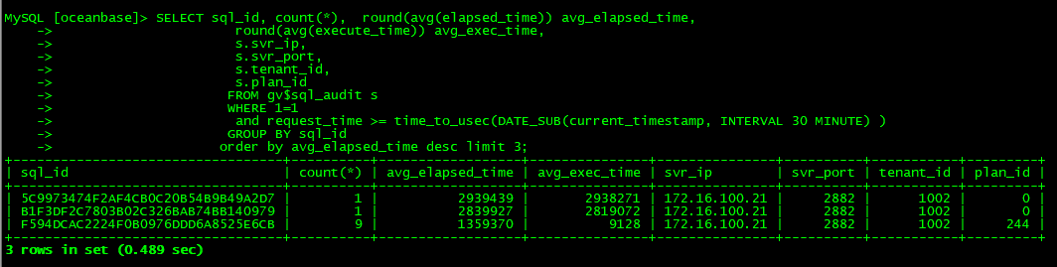

select distinct query_sql from gv$sql_audit where sql_id='5C9973474F2AF4CB0C20B54B9B49A2D7';

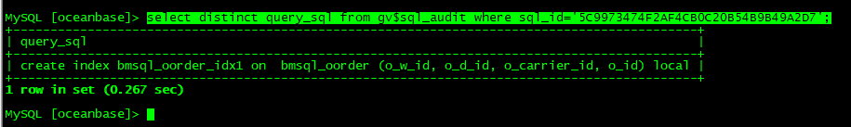

select distinct query_sql from gv$sql_audit where sql_id='B1F3DF2C7803B02C326BAB74BB140979';

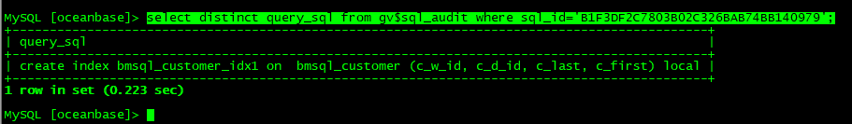

select distinct query_sql from gv$sql_audit where sql_id='F594DCAC2224F0B0976DDD6A8525E6CB'\G;

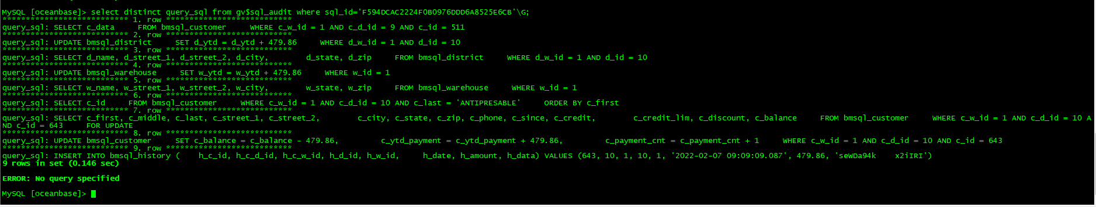

##### 5.3 分析执行计划

obclient -h 172.16.100.21 -utpcc@test_tenant -P2883 -p'password' -c -A tpcc

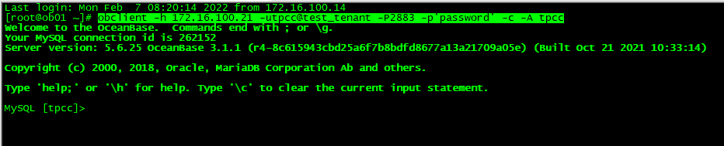

explain SELECT c_data    FROM bmsql_customer    WHERE c_w_id = 1 AND c_d_id = 9 AND c_id = 511;\G

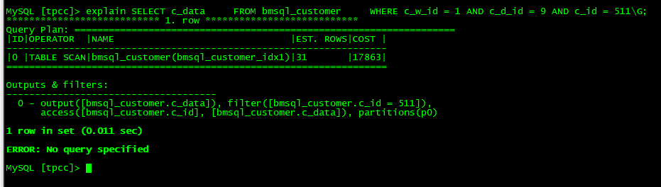

explain UPDATE bmsql_district    SET d_ytd = d_ytd + 479.86    WHERE d_w_id = 1 AND d_id = 10\G;

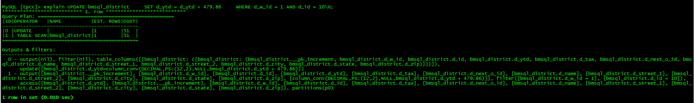

explain SELECT d_name, d_street_1, d_street_2, d_city,       d_state, d_zip    FROM bmsql_district    WHERE d_w_id = 1 AND d_id = 10\G;

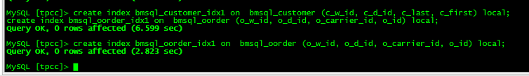

explain UPDATE bmsql_warehouse    SET w_ytd = w_ytd + 479.86    WHERE w_id = 1\G;

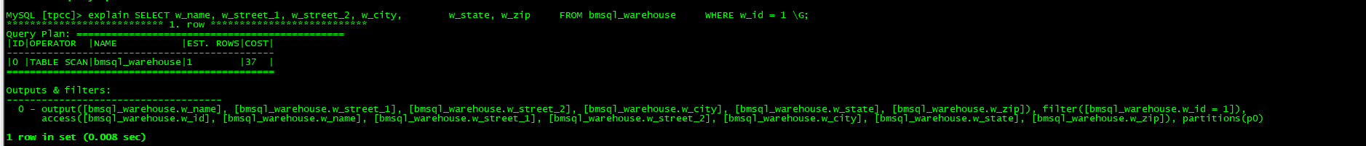

explain SELECT w_name, w_street_1, w_street_2, w_city,       w_state, w_zip    FROM bmsql_warehouse    WHERE w_id = 1 \G;



explain SELECT c_id    FROM bmsql_customer    WHERE c_w_id = 1 AND c_d_id = 10 AND c_last = 'ANTIPRESABLE'    ORDER BY c_first\G;

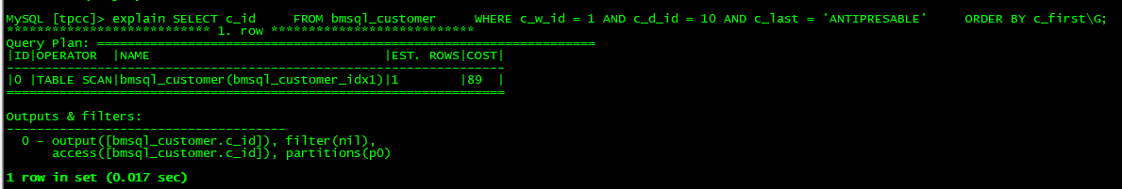

explain SELECT c_first, c_middle, c_last, c_street_1, c_street_2,       c_city, c_state, c_zip, c_phone, c_since, c_credit,       c_credit_lim, c_discount, c_balance    FROM bmsql_customer    WHERE c_w_id = 1 AND c_d_id = 10 AND c_id = 643    FOR UPDATE\G;

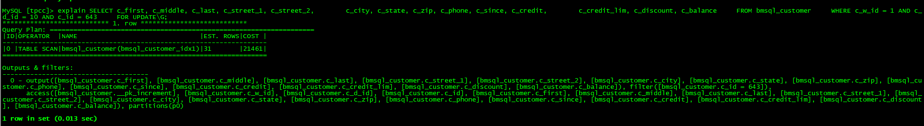

explain UPDATE bmsql_customer    SET c_balance = c_balance - 479.86,        c_ytd_payment = c_ytd_payment + 479.86,        c_payment_cnt = c_payment_cnt + 1    WHERE c_w_id = 1 AND c_d_id = 10 AND c_id = 643\G;

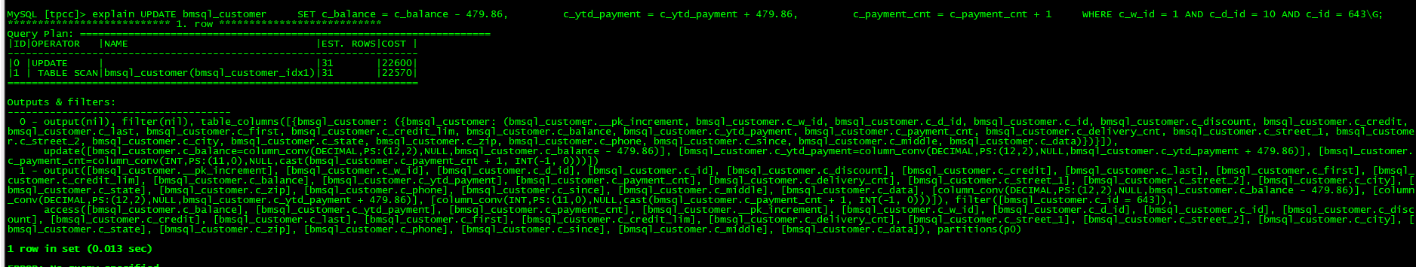

explain INSERT INTO bmsql_history (   h_c_id, h_c_d_id, h_c_w_id, h_d_id, h_w_id,    h_date, h_amount, h_data) VALUES (643, 10, 1, 10, 1, '2022-02-07 09:09:09.087', 479.86, 'seWDa94k   x2iIRI')\G;

