单机部署 OceanBase 集群

- 下载软件
[root@localhost data]# wget https://obbusiness-private.oss-cn-shanghai.aliyuncs.com/download-center/opensource/oceanbase-all-in-one/7/x86_64/oceanbase-all-in-one-4.2.2.1-101000012024030709.el7.x86_64.tar.gz
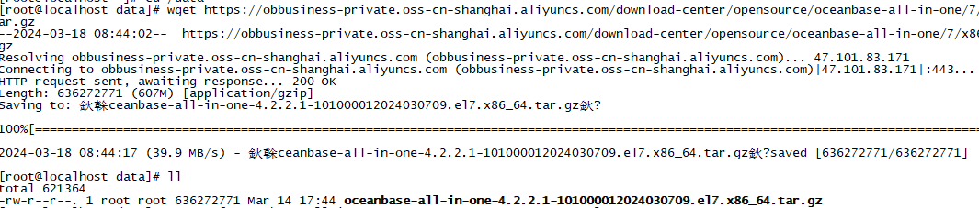

- 解压软件
[root@localhost data]# tar -zxf oceanbase-all-in-one-4.2.2.1-101000012024030709.el7.x86_64.tar.gz
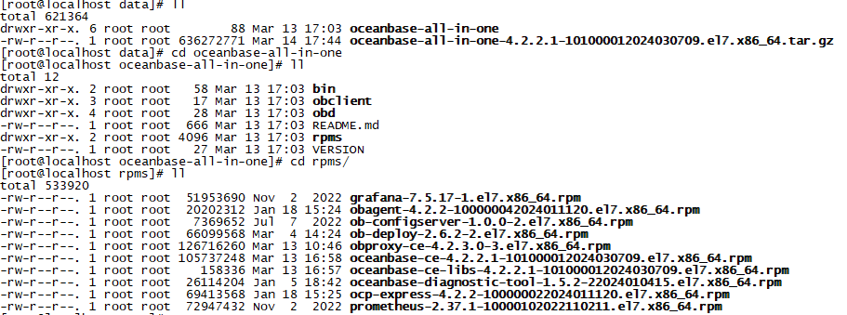

- 创建admin用户

[root@localhost rpms]# useradd admin
[root@localhost rpms]# id admin
uid=1000(admin) gid=1000(admin) groups=1000(admin)

- 安装软件
安装obproxy没有任何依赖，但是安装oceanbase和libs这里碰到了问题
[root@localhost rpms]# yum install /data/oceanbase-ce-libs-4.2.2.1-101000012024030709.el7.x86_64.rpm
Loaded plugins: fastestmirror
Examining /data/oceanbase-ce-libs-4.2.2.1-101000012024030709.el7.x86_64.rpm: oceanbase-ce-libs-4.2.2.1-101000012024030709.el7.x86_64
Marking /data/oceanbase-ce-libs-4.2.2.1-101000012024030709.el7.x86_64.rpm to be installed
Resolving Dependencies
--> Running transaction check
---> Package oceanbase-ce-libs.x86_64 0:4.2.2.1-101000012024030709.el7 will be installed
--> Processing Dependency: jq for package: oceanbase-ce-libs-4.2.2.1-101000012024030709.el7.x86_64
Loading mirror speeds from cached hostfile
--> Finished Dependency Resolution
Error: Package: oceanbase-ce-libs-4.2.2.1-101000012024030709.el7.x86_64 (/oceanbase-ce-libs-4.2.2.1-101000012024030709.el7.x86_64)
Requires: jq
You could try using --skip-broken to work around the problem
You could try running: rpm -Va --nofiles --nodigest
这个jq包需要安装centos的epel源
[root@localhost yum.repos.d]# yum install epel-release
然后才能找到jq包
[root@localhost yum.repos.d]# yum install jq

再安装oceanbase-ce-libs
[root@localhost rpms]# yum install oceanbase-ce-libs-4.2.2.1-101000012024030709.el7.x86_64.rpm
[root@localhost rpms]# ll /home/admin/*/lib
/home/admin/obproxy-4.2.3.0/lib:
total 22060
-rwxr-xr-x. 1 admin admin 22586224 Feb 23 14:49 libstdc++.so.6

/home/admin/oceanbase/lib:
total 460
lrwxrwxrwx. 1 admin admin 15 Mar 18 09:17 libaio.so -> libaio.so.1.0.1
lrwxrwxrwx. 1 admin admin 15 Mar 18 09:17 libaio.so.1 -> libaio.so.1.0.1
-rwxr-xr-x. 1 admin admin 7848 Mar 7 11:27 libaio.so.1.0.1
lrwxrwxrwx. 1 admin admin 15 Mar 18 09:17 libmariadb.so -> libmariadb.so.3
-rwxr-xr-x. 1 admin admin 460680 Mar 7 11:27 libmariadb.so.3
最后安装oceanbase-ce，因为其依赖于oceanbase-ce-libs提供的libmariadb.so.3
[root@localhost rpms]# rpm -ivh oceanbase-ce-4.2.2.1-101000012024030709.el7.x86_64.rpm
Preparing... ################################# [100%]
Updating / installing...
1:oceanbase-ce-4.2.2.1-101000012024################################# [100%]
execute post install script

- 创建运行目录
[root ~] # chown admin:admin /data

[root@localhost ~]# su - admin

[admin@localhost ~]$ mkdir -p /data/{observer01,observer02,observer03,obproxy}

- 启动OB进程
export LD_LIBRARY_PATH=$LD_LIBRARY_PATH:/home/admin/oceanbase/lib/
PATH=$PATH:$HOME/.local/bin:/data/oceanbase-all-in-one/obclient/u01/obclient/bin
将以上内容写入到admin用户的.bash_profile中，然后执行source ~/.bash_profile生效。
[admin@localhost observer01]$ /home/admin/oceanbase/bin/observer -r "192.168.236.30:2882:2881;192.168.236.30:3882:3881;192.168.236.30:4882:4881" -o __min_full_resource_pool_memory=268435456,memory_limit=8G,system_memory=4G,stack_size=512K,cpu_count=4,cache_wash_threshold=1G,workers_per_cpu_quota=10,schema_history_expire_time=1d,net_thread_count=4,sys_bkgd_migration_retry_num=3,minor_freeze_times=10,enable_separate_sys_clog=0,enable_merge_by_turn=False,datafile_size=50G,enable_syslog_recycle=True,max_syslog_file_count=10 -z zone1 -p 2881 -P 2882 -c 1 -d /data/observer01/store -i ens192 -l INFO
/home/admin/oceanbase/bin/observer -r 192.168.236.30:2882:2881;192.168.236.30:3882:3881;192.168.236.30:4882:4881 -o __min_full_resource_pool_memory=268435456,memory_limit=8G,system_memory=4G,stack_size=512K,cpu_count=4,cache_wash_threshold=1G,workers_per_cpu_quota=10,schema_history_expire_time=1d,net_thread_count=4,sys_bkgd_migration_retry_num=3,minor_freeze_times=10,enable_separate_sys_clog=0,enable_merge_by_turn=False,datafile_size=50G,enable_syslog_recycle=True,max_syslog_file_count=10 -z zone1 -p 2881 -P 2882 -c 1 -d /data/observer01/store -i ens192 -l INFO
rs list: 192.168.236.30:2882:2881;192.168.236.30:3882:3881;192.168.236.30:4882:4881
optstr: __min_full_resource_pool_memory=268435456,memory_limit=8G,system_memory=4G,stack_size=512K,cpu_count=4,cache_wash_threshold=1G,workers_per_cpu_quota=10,schema_history_expire_time=1d,net_thread_count=4,sys_bkgd_migration_retry_num=3,minor_freeze_times=10,enable_separate_sys_clog=0,enable_merge_by_turn=False,datafile_size=50G,enable_syslog_recycle=True,max_syslog_file_count=10
zone: zone1
mysql port: 2881
rpc port: 2882
cluster id: 1
data_dir: /data/observer01/store
devname: ens192
log level: INFO
日志显示参数无效 __min_full_resource_pool_memory=268435456
[2024-03-18 10:07:27.919502] INFO [SERVER] parse_mode (ob_server.cpp:227) [1487][observer][T0][Y0-0000000000000000-0-0] [lt=13] set normal mode
[2024-03-18 10:07:27.919534] EDIAG [SHARE] operator() (ob_common_config.cpp:366) [1487][observer][T0][Y0-0000000000000000-0-0] [lt=12][errcode=-4147] Invalid config, value out of [1073741824,) (for ref
erence only). name=__min_full_resource_pool_memory, value=268435456, ret=-4147 BACKTRACE:0x12a0517c 0x53dc305 0x554ed55 0x554e9e8 0x554e64c 0xffcaa17 0xff8aad7 0xff8a288 0xa85e331 0xa854049 0x73fe460 0
x2aaddf19f555 0x56c3cbf

cd /data/observer01/ && /home/admin/oceanbase/bin/observer -r "192.168.236.30:2882:2881;192.168.236.30:3882:3881;192.168.236.30:4882:4881" -o __min_full_resource_pool_memory=1073741824,memory_limit=16G,system_memory=4G,stack_size=512K,cpu_count=4,cache_wash_threshold=1G,workers_per_cpu_quota=10,schema_history_expire_time=1d,net_thread_count=4,sys_bkgd_migration_retry_num=3,minor_freeze_times=10,enable_separate_sys_clog=0,enable_merge_by_turn=False,datafile_size=50G,enable_syslog_recycle=True,max_syslog_file_count=10 -z zone1 -p 2881 -P 2882 -c 1 -d /data/observer01/store -i ens192 -l INFO
根据提示修改成__min_full_resource_pool_memory=1073741824
cd /data/observer02/ && /home/admin/oceanbase/bin/observer -r "192.168.236.30:2882:2881;192.168.236.30:3882:3881;192.168.236.30:4882:4881" -o __min_full_resource_pool_memory=1073741824,memory_limit=16G,system_memory=4G,stack_size=512K,cpu_count=4,cache_wash_threshold=1G,workers_per_cpu_quota=10,schema_history_expire_time=1d,net_thread_count=4,sys_bkgd_migration_retry_num=3,minor_freeze_times=10,enable_separate_sys_clog=0,enable_merge_by_turn=False,datafile_size=50G,enable_syslog_recycle=True,max_syslog_file_count=10 -z zone2 -p 3881 -P 3882 -c 1 -d /data/observer02/store -i ens192 -l INFO

cd /data/observer03/ && /home/admin/oceanbase/bin/observer -r "192.168.236.30:2882:2881;192.168.236.30:3882:3881;192.168.236.30:4882:4881" -o __min_full_resource_pool_memory=1073741824,memory_limit=16G,system_memory=4G,stack_size=512K,cpu_count=4,cache_wash_threshold=1G,workers_per_cpu_quota=10,schema_history_expire_time=1d,net_thread_count=4,sys_bkgd_migration_retry_num=3,minor_freeze_times=10,enable_separate_sys_clog=0,enable_merge_by_turn=False,datafile_size=50G,enable_syslog_recycle=True,max_syslog_file_count=10 -z zone3 -p 4881 -P 4882 -c 1 -d /data/observer03/store -i ens192 -l INFO

检查端口
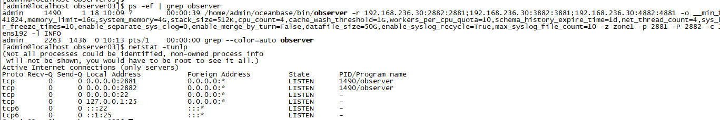

- 初始化集群
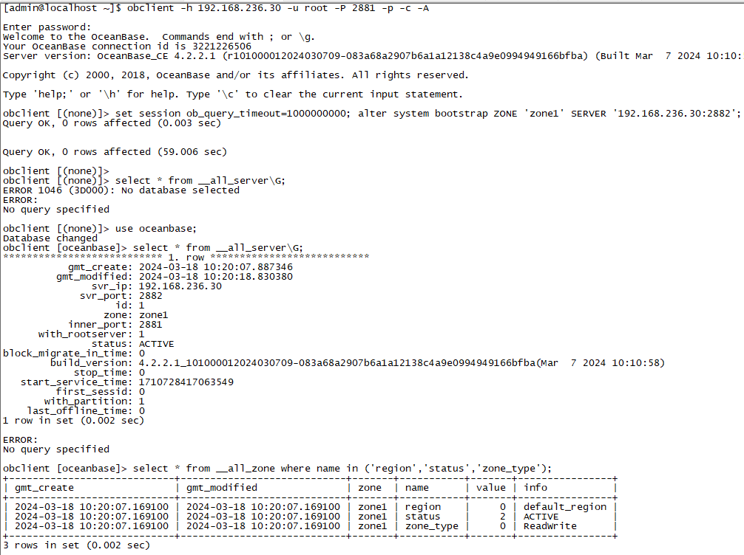

- 创建租户

- 登录租户
