# 1 BenchmarkSQL运行

## 1.1配置BenchmarkSQL

下载BenchmarkSQL，并解压

wget <https://jaist.dl.sourceforge.net/project/benchmarksql/benchmarksql-5.0.zip>

[root@oceanbase ~]# unzip benchmarksql-5.0.zip

下载JDBC驱动

[OceanBase 公有云版下载 - 云数据库工具下载 -OceanBase 数据库下载中心](https://www.oceanbase.com/softwarecenter-cloud)

[root@oceanbase ~]# mv oceanbase-client-2.4.1.jar /root/benchmarksql-5.0/lib/oracle

[root@oceanbase ~]# cd /root/benchmarksql-5.0/lib/oracle

[root@oceanbase oracle]# chmod 777 oceanbase-client-2.4.1.jar

安装ant，并执行

[root@oceanbase oracle]# yum install -y ant

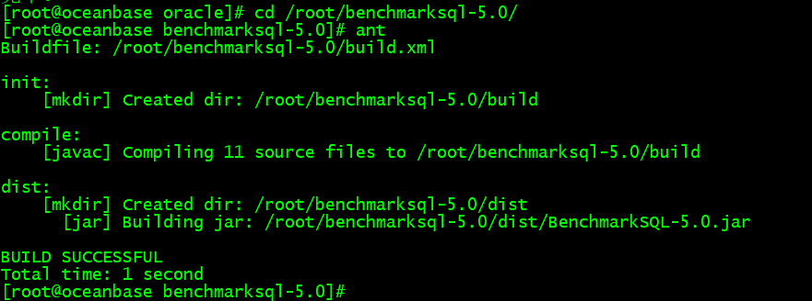

编辑配置文件

[root@oceanbase run]# vi props.ob

db=oracle

driver=com.alipay.oceanbase.obproxy.mysql.jdbc.Driver

conn=jdbc:oceanbase://127.0.0.1:2883/tpcc?useUnicode=true&characterEncoding=utf-8

user=root

password=rootroot

db=oracle

driver=com.alipay.oceanbase.obproxy.mysql.jdbc.Driver

conn=jdbc:oceanbase://127.0.0.1:2883/tpcc?useUnicode=true&characterEncoding=utf-8

user=root

password=Zy1441128

warehouses=2

loadWorkers=1

terminals=5

//To run specified transactions per terminal- runMins must equal zero

runTxnsPerTerminal=0

//To run for specified minutes- runTxnsPerTerminal must equal zero

runMins=5

//Number of total transactions per minute

limitTxnsPerMin=0

//Set to true to run in 4.x compatible mode. Set to false to use the

//entire configured database evenly.

terminalWarehouseFixed=true

//The following five values must add up to 100

newOrderWeight=45

paymentWeight=43

orderStatusWeight=4

deliveryWeight=4

stockLevelWeight=4

// Directory name to create for collecting detailed result data.

// Comment this out to suppress.

resultDirectory=my_result_%tY-%tm-%td_%tH%tM%tS

osCollectorScript=./misc/os_collector_linux.py

osCollectorInterval=1

~

创建对应数据库

obclient -h 192.168.6.31 -P 2883 -uroot -pZy1441128 -c -A

create database tpcc;

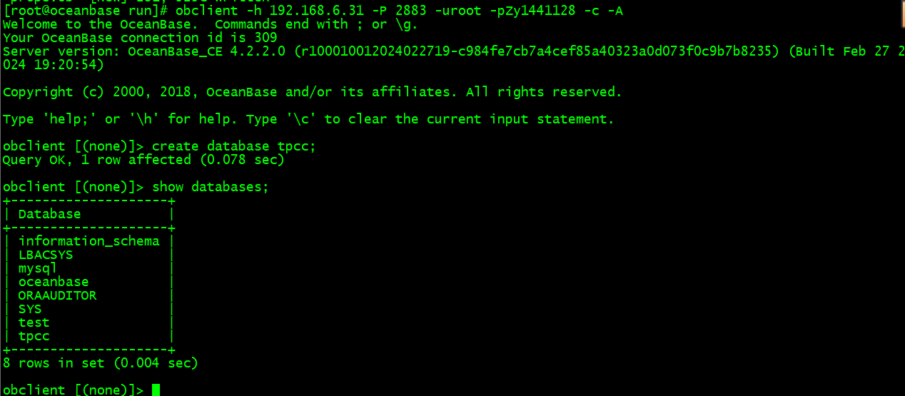

## 1.2 运行TPCC

运行脚本

[root@oceanbase run]# ./runDatabaseBuild.sh props.ob

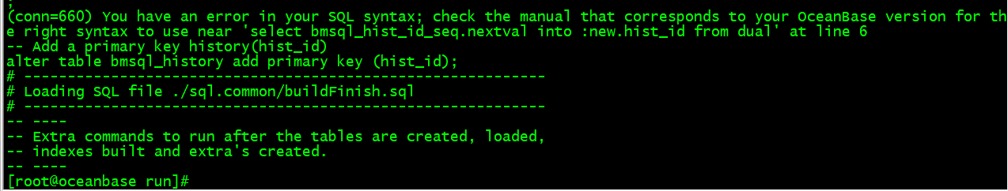

由于是oracle语法，oracle实现自增列用的是序列+触发器。oceanbase语法不支持。我们直接手动创建自增列即可

ALTER TABLE bmsql_history MODIFY hist_id INTEGER AUTO_INCREMENT PRIMARY KEY;

如果不创建在跑runBenchmark.sh时会报如下错误

Caused by: java.sql.SQLException: Field 'hist_id' doesn't have a default value

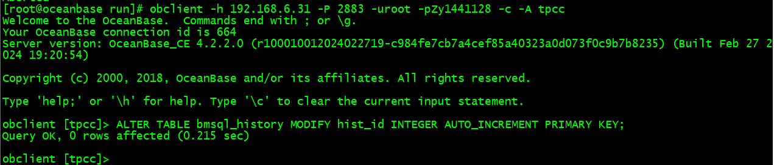

开始TPCC测试

./runBenchmark.sh props.ob

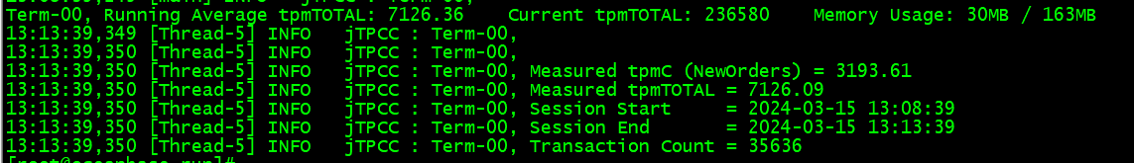

# 2 查看执行计划

查看 processlist 确认有会话连接到集群

show full process list;

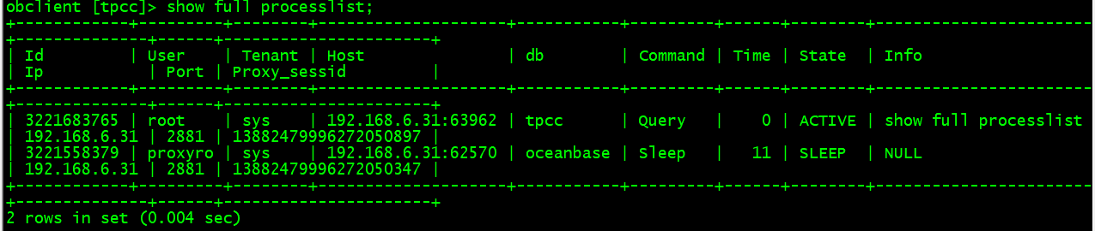

查看 TOP SQL,使用OceanBase数据库

SELECT sql_id, count(*), round(avg(elapsed_time)) avg_elapsed_time, round(avg(execute_time)) avg_exec_time

FROM gv$ob_sql_audit s

WHERE 1=1

and db_name= 'tpcc'

and request_time >= time_to_usec(DATE_SUB(current_timestamp, INTERVAL 30 MINUTE) )

GROUP BY sql_id

order by avg_elapsed_time desc limit 3;

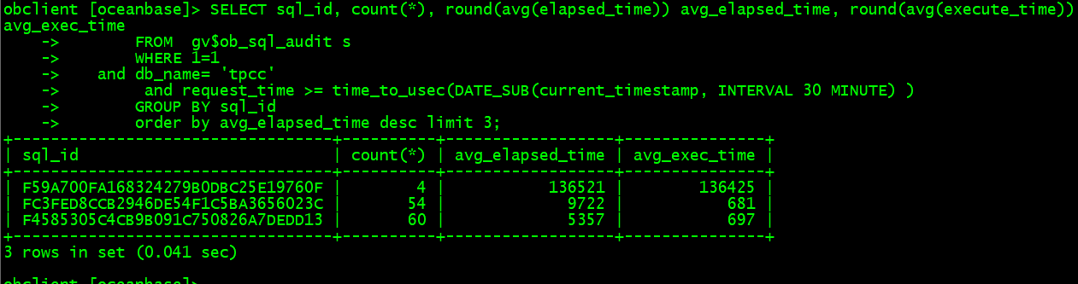

根据 sql_id 定位具体的 sql 语句 ，并查询 SVR_IP,SVR_PORT,TENANT_ID,PLAN_ID 用于获取真实实际的执行计划

select SVR_IP,SVR_PORT,TENANT_ID,PLAN_ID,QUERY_SQL from gv$ob_sql_audit where sql_id='F59A700FA168324279B0DBC25E19760F' limit 1;

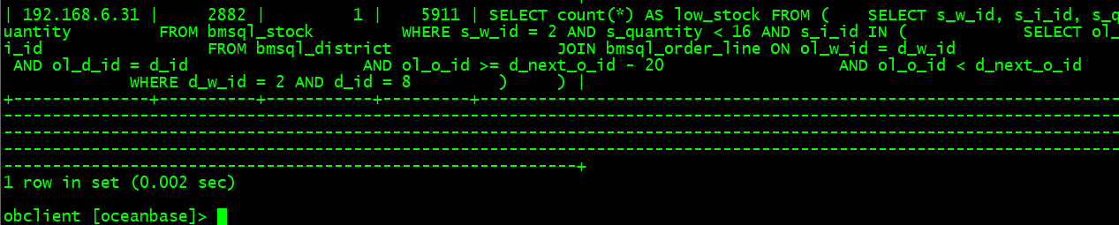

查看执行计划

obclient [oceanbase]> use tpcc

obclient [tpcc]> explain SELECT count(*) AS low_stock FROM ( SELECT s_w_id, s_i_id, s_quantity FROM bmsql_stock WHERE s_w_id = 2 AND s_quantity < 16 AND s_i_id IN ( SELECT ol_i_id FROM bmsql_district JOIN bmsql_order_line ON ol_w_id = d_w_id AND ol_d_id = d_id AND ol_o_id >= d_next_o_id - 20 AND ol_o_id < d_next_o_id WHERE d_w_id = 2 AND d_id = 8 ) );

+-----------------------------------------------------------------------------------------------------------------------------------------------------------------------+

| Query Plan |

+-----------------------------------------------------------------------------------------------------------------------------------------------------------------------+

| ==================================================================== |

| |ID|OPERATOR |NAME |EST.ROWS|EST.TIME(us)| |

| -------------------------------------------------------------------- |

| |0 |SCALAR GROUP BY | |1 |44 | |

| |1 |└─HASH RIGHT SEMI JOIN | |4 |44 | |

| |2 | ├─SUBPLAN SCAN |VIEW1 |4 |16 | |

| |3 | │ └─NESTED-LOOP JOIN | |4 |16 | |

| |4 | │ ├─TABLE RANGE SCAN|bmsql_order_line|73 |12 | |

| |5 | │ └─MATERIAL | |1 |3 | |

| |6 | │ └─TABLE GET |bmsql_district |1 |3 | |

| |7 | └─TABLE RANGE SCAN |bmsql_stock |98 |19 | |

| ==================================================================== |

| Outputs & filters: |

| ------------------------------------- |

| 0 - output([T_FUN_COUNT(*)]), filter(nil), rowset=256 |

| group(nil), agg_func([T_FUN_COUNT(*)]) |

| 1 - output(nil), filter(nil), rowset=256 |

| equal_conds([bmsql_stock.s_i_id = VIEW1.ol_i_id]), other_conds(nil) |

| 2 - output([VIEW1.ol_i_id]), filter(nil), rowset=256 |

| access([VIEW1.ol_i_id]) |

| 3 - output([bmsql_order_line.ol_i_id]), filter(nil), rowset=256 |

| conds([bmsql_order_line.ol_o_id < bmsql_district.d_next_o_id], [bmsql_order_line.ol_o_id >= bmsql_district.d_next_o_id - 20]), nl_params_(nil), use_batch=false |

| 4 - output([bmsql_order_line.ol_o_id], [bmsql_order_line.ol_i_id]), filter(nil), rowset=256 |

| access([bmsql_order_line.ol_o_id], [bmsql_order_line.ol_i_id]), partitions(p0) |

| is_index_back=false, is_global_index=false, |

| range_key([bmsql_order_line.ol_w_id], [bmsql_order_line.ol_d_id], [bmsql_order_line.ol_o_id], [bmsql_order_line.ol_number]), range(2,8,MIN,MIN ; 2, |

| 8,MAX,MAX), |

| range_cond([bmsql_order_line.ol_w_id = 2], [bmsql_order_line.ol_d_id = 8]) |

| 5 - output([bmsql_district.d_next_o_id], [bmsql_district.d_next_o_id - 20]), filter(nil), rowset=256 |

| 6 - output([bmsql_district.d_next_o_id], [bmsql_district.d_next_o_id - 20]), filter([bmsql_district.d_next_o_id > bmsql_district.d_next_o_id - 20]), rowset=256 |

| access([bmsql_district.d_next_o_id]), partitions(p0) |

| is_index_back=false, is_global_index=false, filter_before_indexback[false], |

| range_key([bmsql_district.d_w_id], [bmsql_district.d_id]), range[2,8 ; 2,8], |

| range_cond([bmsql_district.d_w_id = 2], [bmsql_district.d_id = 8]) |

| 7 - output([bmsql_stock.s_i_id]), filter([bmsql_stock.s_quantity < 16]), rowset=256 |

| access([bmsql_stock.s_i_id], [bmsql_stock.s_quantity]), partitions(p0) |

| is_index_back=false, is_global_index=false, filter_before_indexback[false], |

| range_key([bmsql_stock.s_w_id], [bmsql_stock.s_i_id]), range(2,MIN ; 2,MAX), |

| range_cond([bmsql_stock.s_w_id = 2]) |

+-----------------------------------------------------------------------------------------------------------------------------------------------------------------------+

39 rows in set (0.066 sec)

# 查看真实的执行计划

根据上面查到的 SVR_IP,SVR_PORT,TENANT_ID,PLAN_ID 查询 GV$OB_PLAN_CACHE_PLAN_EXPLAIN以获取真实实际的执行计划

obclient [oceanbase]> select * from GV$OB_PLAN_CACHE_PLAN_EXPLAIN where SVR_IP = '192.168.6.31' and SVR_PORT=2882 and TENANT_ID=1 and PLAN_ID=5911;

+-----------+--------------+----------+---------+------------+--------------+--------------------------+------------------+------+------+--------------------------------------------------------------------------------------------------------------------------------------------+

| TENANT_ID | SVR_IP | SVR_PORT | PLAN_ID | PLAN_DEPTH | PLAN_LINE_ID | OPERATOR | NAME | ROWS | COST | PROPERTY |

+-----------+--------------+----------+---------+------------+--------------+--------------------------+------------------+------+------+--------------------------------------------------------------------------------------------------------------------------------------------+

| 1 | 192.168.6.31 | 2882 | 5911 | 0 | 0 | PHY_SCALAR_AGGREGATE | NULL | 1 | 39 | NULL |

| 1 | 192.168.6.31 | 2882 | 5911 | 1 | 1 | PHY_NESTED_LOOP_JOIN | NULL | 2 | 39 | NULL |

| 1 | 192.168.6.31 | 2882 | 5911 | 2 | 2 | PHY_SUBPLAN_SCAN | NULL | 2 | 10 | NULL |

| 1 | 192.168.6.31 | 2882 | 5911 | 3 | 3 | PHY_HASH_DISTINCT | NULL | 2 | 10 | NULL |

| 1 | 192.168.6.31 | 2882 | 5911 | 4 | 4 | PHY_NESTED_LOOP_JOIN | NULL | 2 | 9 | NULL |

| 1 | 192.168.6.31 | 2882 | 5911 | 5 | 5 | PHY_TABLE_SCAN | bmsql_order_line | 28 | 6 | table_rows:379334, physical_range_rows:28, logical_range_rows:28, index_back_rows:0, output_rows:28, avaiable_index_name[bmsql_order_line] |

| 1 | 192.168.6.31 | 2882 | 5911 | 5 | 6 | PHY_MATERIAL | NULL | 1 | 2 | NULL |

| 1 | 192.168.6.31 | 2882 | 5911 | 6 | 7 | PHY_TABLE_SCAN | bmsql_district | 1 | 2 | table_rows:20, physical_range_rows:1, logical_range_rows:1, index_back_rows:0, output_rows:1, avaiable_index_name[bmsql_district] |

| 1 | 192.168.6.31 | 2882 | 5911 | 2 | 8 | PHY_TABLE_SCAN | bmsql_stock | 1 | 20 | table_rows:100049, physical_range_rows:1, logical_range_rows:1, index_back_rows:0, output_rows:0, avaiable_index_name[bmsql_stock] |

+-----------+--------------+----------+---------+------------+--------------+--------------------------+------------------+------+------+--------------------------------------------------------------------------------------------------------------------------------------------+

9 rows in set (0.001 sec)