迁移MySQL数据到OceanBase集群
- mysqldump迁移
- mysqldump导出MySQL数据
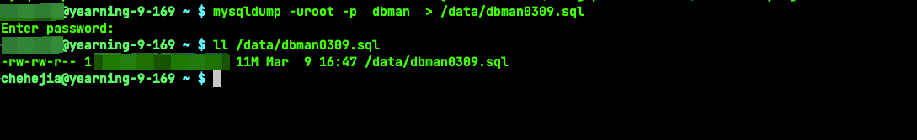
- mysql导入OceanBase集群
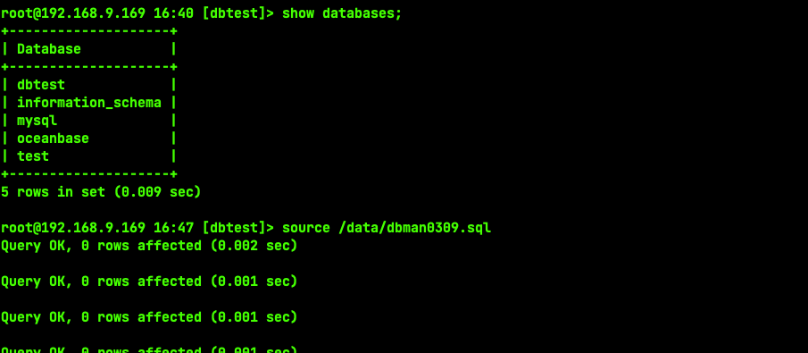
- datax迁移
- 下载datax
wget http://datax-opensource.oss-cn-hangzhou.aliyuncs.com/datax.tar.gz
- 配置文件
cat /data/my2ob.json
{
"job": {
"setting": {
"speed": {
"channel": 2,
},
"errorLimit": {
"record": 10
}
},
"content": [
{
"reader": {
"name": "mysqlreader",
"parameter": {
"username": "root",
"password": "XXXXXXXXX",
"splitPk": "id",
"column": ["*"],
"connection": [
{
"jdbcUrl": [
"jdbc:mysql://192.168.9.169:3306/dbman"
],
"table": [
"env_ips"
]
}
]
}
},
"writer": {
"name": "oceanbasev10writer",
"parameter": {
"writeMode": "insert",
"username": "root",
"password": "XXXXXXXX",
"writerThreadCount": 5,
"column": [
"*"
],
"connection": [
{
"jdbcUrl": "||_dsc_ob10_dsc_||obtest:obmysql||_dsc_ob10_dsc_||jdbc:oceanbase://127.0.0.1:2883/dbtest?useUnicode=true&characterEncoding=utf-8",
"table": [
"t2222"
]
}
]
}
}
}
]
}
}
- 运行
python2 datax/bin/datax.py /data/my2ob.json

