手动安装企业OB三节点

1. 基础环境

|  |  |  |  |  |
| --- | --- | --- | --- | --- |
| 主机 | 地址 | 系统 | 配置 |  |
| Observer1 | 172.20.16.116 | Linux 7.7 | 5C40G |  |
| Observer2 | 172.20.16.117 | Linux 7.7 | 5C40G |  |
| Observer3 | 172.20.16.118 | Linux 7.7 | 5C40G |  |

1. 磁盘规划

|  |  |  |
| --- | --- | --- |
| 目录 | 大小 | 挂载点 |
| /home | 100G | /home |
| /data/1 | 300G | /data/1 |
| /data/log1 | 200G | /data/log1 |

1. 上传软件包

|  |  |
| --- | --- |
|  |  |
| Oceanbase | oceanbase-4.2.1.3-103050012024012511.el7.x86_64.rpm |
| Obproxy | obproxy-4.2.3.0-20240131105459.el7.x86_64.rpm |

1. 初始化目录

su - admin

mkdir -p /data/1/obdemo/{etc3,sstable,slog}

mkdir -p /data/log1/obdemo/{clog,etc2}

mkdir -p /home/admin/oceanbase/store/obdemo

for t in {etc3,sstable,slog};do ln -s /data/1/obdemo/$t /home/admin/oceanbase/store/obdemo/$t; done

for t in {clog,etc2};do ln -s /data/log1/obdemo/$t /home/admin/oceanbase/store/obdemo/$t; done

observer1



Observer2



Observer3



检查结果

cd /home/admin/oceanbase

tree store/

store/

`-- obdemo

|-- clog -> /data/log1/obdemo/clog

|-- etc2 -> /data/log1/obdemo/etc2

|-- etc3 -> /data/1/obdemo/etc3

|-- slog -> /data/1/obdemo/slog

`-- sstable -> /data/1/obdemo/sstable

Observer1

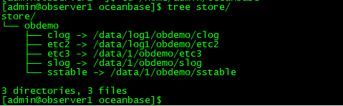

Observer2

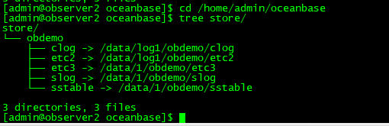

Observer3

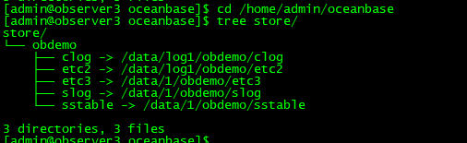

1. 安装 oceanbase 数据库

Observer1

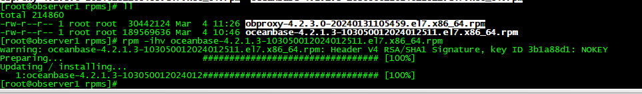

Observer2

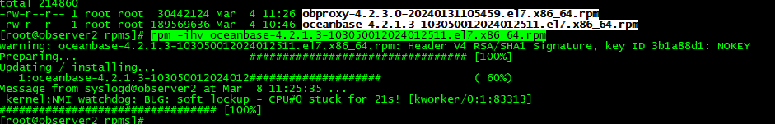

Observer3

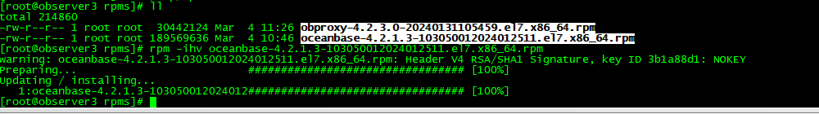

1. 初始化数据库

Observer1 初始化

cd /home/admin/oceanbase && /home/admin/oceanbase/bin/observer -I 172.20.16.116 -P 2882 -p 2881 -z zone1 -d /home/admin/oceanbase/store/obdemo -r '172.20.16.116:2882:2881' -c 10001 -n obdemo -o "system_memory=30G,datafile_size=300G,config_additional_dir=/data/1/obdemo/etc3;/data/log1/obdemo/etc2"

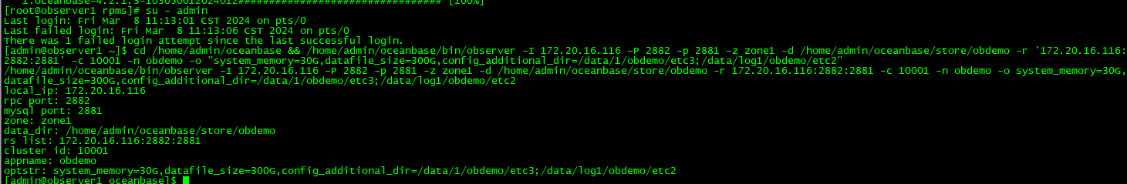

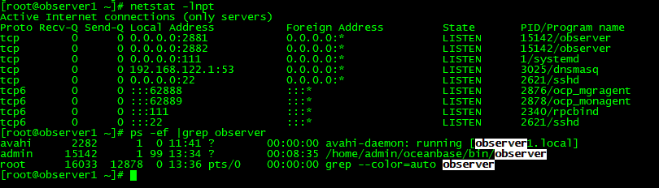

Observer2初始化

su - admin

cd /home/admin/oceanbase && /home/admin/oceanbase/bin/observer -I 172.20.16.117 -P 2882 -p 2881 -z zone1 -d /home/admin/oceanbase/store/ob_cluster_01 -r '10.10.10.1:2882:2881' -c 10001 -n ob_cluster_01 -o "system_memory=30G,datafile_size=300G,config_additional_dir=/data/1/ob_cluster_01/etc3;/data/log1/ob_cluster_01/etc2"

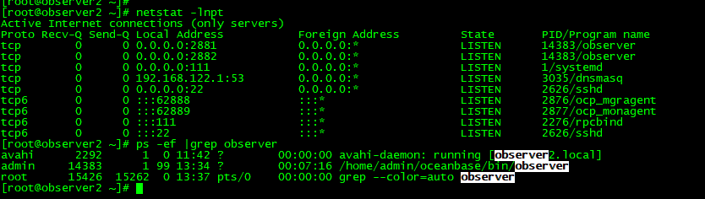

Observer3始化

su - admin

cd /home/admin/oceanbase && /home/admin/oceanbase/bin/observer -I 172.20.16.118 -P 2882 -p 2881 -z zone1 -d /home/admin/oceanbase/store/ob_cluster_01 -r '10.10.10.1:2882:2881' -c 10001 -n ob_cluster_01 -o "system_memory=30G,datafile_size=300G,config_additional_dir=/data/1/ob_cluster_01/etc3;/data/log1/ob_cluster_01/etc2"

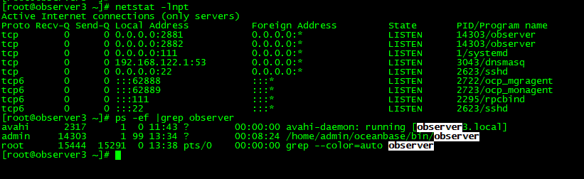

7、集群 bootstrap 操作

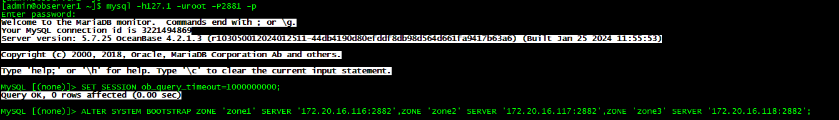

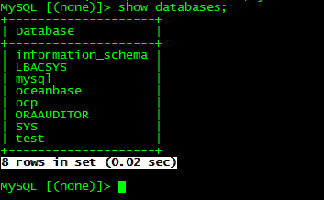

1. 修改root密码

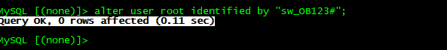

1. 创建业务租户

查看资源单元规格

select * from __all_unit_config;

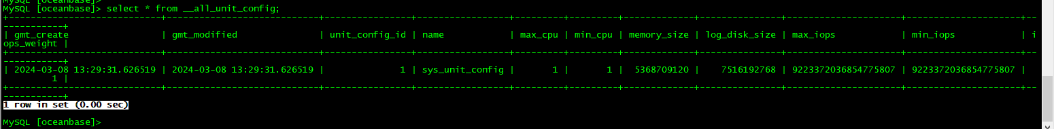

创建单元规格

create resource unit sw maxcpu=1,memory_size='6G‘；

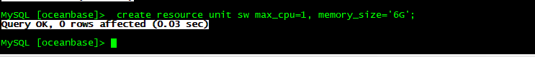

创建资源池

create resource pool sw_pool unit='sw',unit_num=1,zone_list=('zone1','zone2','zone3');



查看资源分配细节

select t1.name resource_pool_name,t2.name unit_config_name,t2.max_cpu,t2.min_cpu,truncate(t2.memory_size/1024/1024/1024,2) memory_size_gb,t3.unit_id,t3.zone,concat(t3.svr_ip,':',t3.svr_port) observer,t4.tenant_id,t4.tenant_name from __all_resource_pool t1 join __all_unit_config t2 on (t1.unit_config_id=t2.unit_config_id) join __all_unit t3 on (t1.resource_pool_id = t3.resource_pool_id) left join __all_tenant t4 on (t1.tenant_id=t4.tenant_id)order by t1.resource_pool_id, t2.unit_config_id, t3.unit_id;

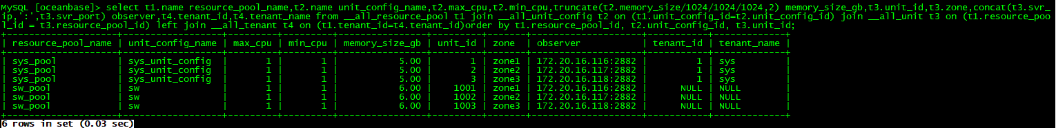

创建租户

create tenant sw_tenant resource_pool_list=('sw_pool'),primary_zone='zone1;zone2;zone3',comment 'my tenant',charset='utf8mb4',COLLATE='utf8mb4_bin' set ob_tcp_invited_nodes='%',lower_case_table_names=0;



测试登录成功

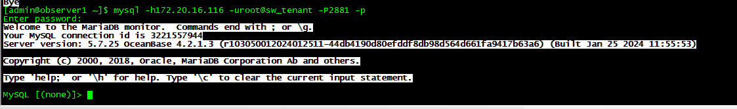

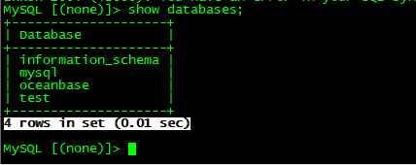

创建数据库并插入数据

