插入sql :
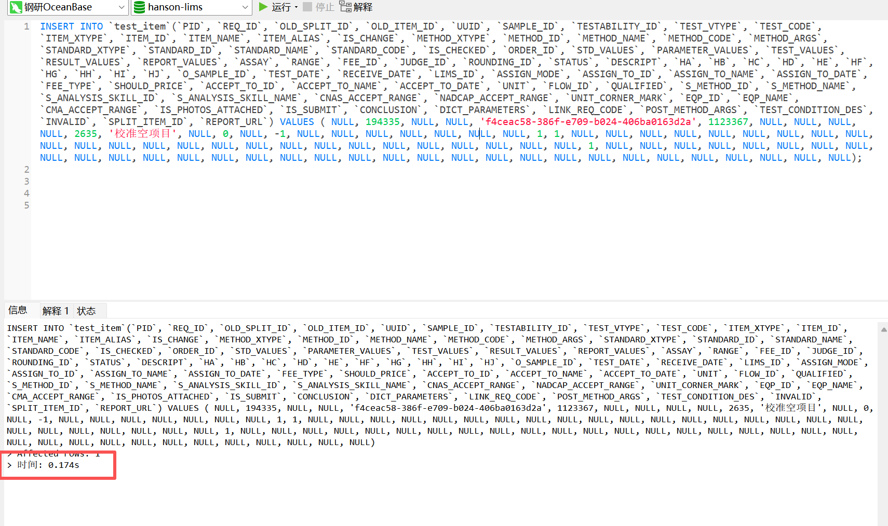
执行计划
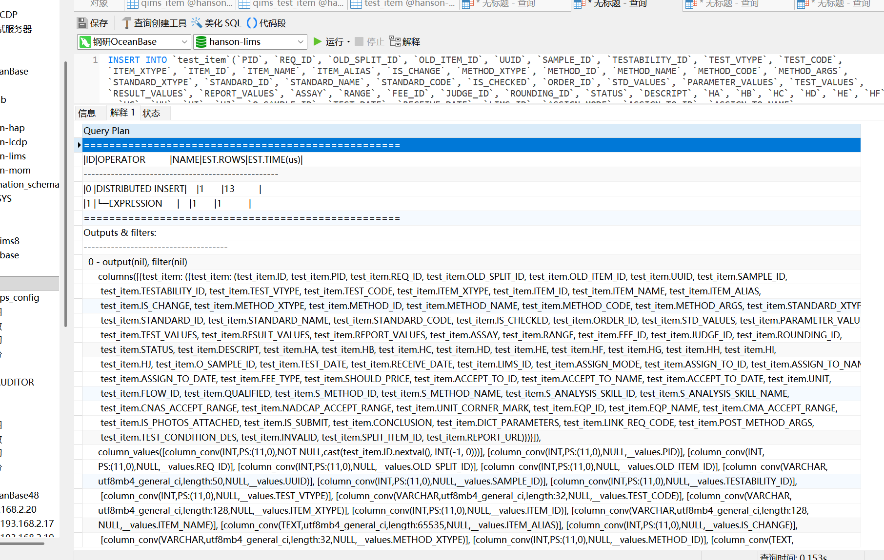

Sql 如下：INSERT INTO `test_item`(`PID`, `REQ_ID`, `OLD_SPLIT_ID`, `OLD_ITEM_ID`, `UUID`, `SAMPLE_ID`, `TESTABILITY_ID`, `TEST_VTYPE`, `TEST_CODE`, `ITEM_XTYPE`, `ITEM_ID`, `ITEM_NAME`, `ITEM_ALIAS`, `IS_CHANGE`, `METHOD_XTYPE`, `METHOD_ID`, `METHOD_NAME`, `METHOD_CODE`, `METHOD_ARGS`, `STANDARD_XTYPE`, `STANDARD_ID`, `STANDARD_NAME`, `STANDARD_CODE`, `IS_CHECKED`, `ORDER_ID`, `STD_VALUES`, `PARAMETER_VALUES`, `TEST_VALUES`, `RESULT_VALUES`, `REPORT_VALUES`, `ASSAY`, `RANGE`, `FEE_ID`, `JUDGE_ID`, `ROUNDING_ID`, `STATUS`, `DESCRIPT`, `HA`, `HB`, `HC`, `HD`, `HE`, `HF`, `HG`, `HH`, `HI`, `HJ`, `O_SAMPLE_ID`, `TEST_DATE`, `RECEIVE_DATE`, `LIMS_ID`, `ASSIGN_MODE`, `ASSIGN_TO_ID`, `ASSIGN_TO_NAME`, `ASSIGN_TO_DATE`, `FEE_TYPE`, `SHOULD_PRICE`, `ACCEPT_TO_ID`, `ACCEPT_TO_NAME`, `ACCEPT_TO_DATE`, `UNIT`, `FLOW_ID`, `QUALIFIED`, `S_METHOD_ID`, `S_METHOD_NAME`, `S_ANALYSIS_SKILL_ID`, `S_ANALYSIS_SKILL_NAME`, `CNAS_ACCEPT_RANGE`, `NADCAP_ACCEPT_RANGE`, `UNIT_CORNER_MARK`, `EQP_ID`, `EQP_NAME`, `CMA_ACCEPT_RANGE`, `IS_PHOTOS_ATTACHED`, `IS_SUBMIT`, `CONCLUSION`, `DICT_PARAMETERS`, `LINK_REQ_CODE`, `POST_METHOD_ARGS`, `TEST_CONDITION_DES`, `INVALID`, `SPLIT_ITEM_ID`, `REPORT_URL`) VALUES ( NULL, 194335, NULL, NULL, 'f4ceac58-386f-e709-b024-406ba0163d2a', 1123367, NULL, NULL, NULL, NULL, 2635, '校准空项目', NULL, 0, NULL, -1, NULL, NULL, NULL, NULL, NULL, NULL, NULL, 1, 1, NULL, NULL, NULL, NULL, NULL, NULL, NULL, NULL, NULL, NULL, NULL, NULL, NULL, NULL, NULL, NULL, NULL, NULL, NULL, NULL, NULL, NULL, NULL, NULL, NULL, 1, NULL, NULL, NULL, NULL, NULL, NULL, NULL, NULL, NULL, NULL, NULL, NULL, NULL, NULL, NULL, NULL, NULL, NULL, NULL, NULL, NULL, NULL, NULL, NULL, NULL, NULL, NULL, NULL, NULL, NULL, NULL, NULL);

- 慢sql: SELECT * FROM `test_item` WHERE ITEM_NAME LIKE '&C&' 。
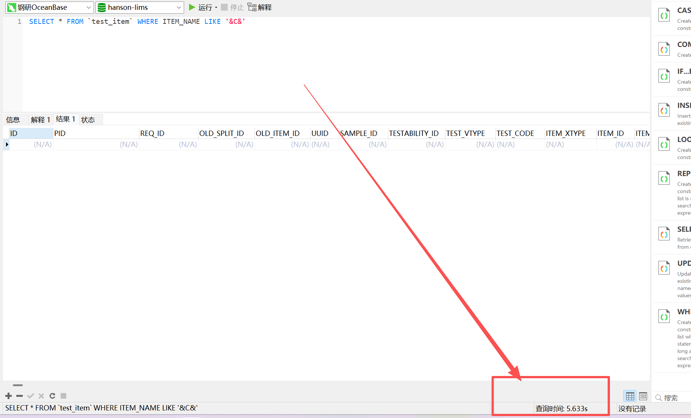
执行计划
